Financial Lit Name: _______________________

______________ _____________

WS Assessment

Target 26:

Set and Venn diagram

**I can:**

* Use set notation and understand the null set
* Determine the universal set for a given context
* Use Venn diagrams and set notation to illustrate the intersection, union and complements of sets
* Illustrate disjoint sets, subsets and overlapping sets with diagrams
* Use Venn diagrams and problem-solving strategies to solve logic problems

**Unit 12 Math Topics:**

* Boolean Algebra
* Venn Diagram

It is natural for us to classify items into groups, or **sets**, and consider how they interact with each other. In this target, we will use sets and Venn diagrams to visualize relationships between groups and represent survey data.

A **set** is a collection of items or things. Each item in a set is called a member or element.

The set of all even numbers The set of all books written about travel to Chile

Sets defined by listing the elements of the set, order is not important

{red, orange, yellow, green, blue, indigo, purple} {1, 2, 3} is equivalent to the set {3, 1, 2}

Julia, Keenan, Jae and Colin took a test. They got the following scores: 70, 95, 85 and 70. Let P be the set of test takers and S be the set of test scores. List the elements of each set using set notation.

P = ? S = ?

Let *A* = {1, 2, 3, 4} To notate that 2 is element of the set, we’d write 2 $∈$*A*

The symbol $∈$ means “is an element of”.



Consider these three sets

*A* = the set of all even numbers *B* = {2, 4, 6} *C* = {2, 3, 4, 6}

True of False

*B* ⊂ *A*  *B* ⊂ *C* *C* ⊂ *A C* ⊂ *B*

The **Null** Set. It is possible to have a set with nothing in it. This set called the null set or empty set.

If G is a null, we write G = { }, or G = Ø.

Consider the sets:

*A* = {red, green, blue} *B* = {red, yellow, orange} *C* = {red, orange, yellow, green, blue, purple}

Find *A* ⋃ *B* Find *A* ⋂ *B*  Find *Ac* ⋂ *C*

*H* = {cat, dog, rabbit, mouse}, *F* = {dog, cow, duck, pig, rabbit} *W* = {duck, rabbit, deer, frog, mouse}

Find (*H* ⋂ *F*) ⋃ *W H* ⋂ (*F* ⋃ *W*) (*H* ⋂ *F*)*c* ⋂ *W*



|  |  |  |
| --- | --- | --- |
| *A* ⋃ *B* contains all elements in *either* set. | *A* ⋂ *B* contains only those elements in both sets – in the overlap of the circles | *Ac* will contain all elements *not* in the set A. *Ac* ⋂ *B* will contain the elements in set *B* that are not in set *A*. |

Write the notation for the following

|  |  |  |
| --- | --- | --- |
|  |  |  |

We use Venn diagrams to illustrate quantities, data, or frequencies.

A survey asks 200 people, “What beverage(s) do you drink in the morning?” and offers three choices: tea only, coffee only, and both coffee and tea. Thirty report drinking only tea in the morning, 80 report drinking only coffee in the morning, and 40 report drinking both. Draw a Venn diagram

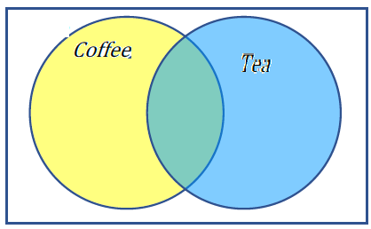How many people drink tea in the morning? How many people drink neither tea nor coffee?

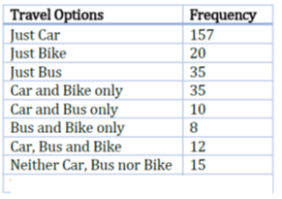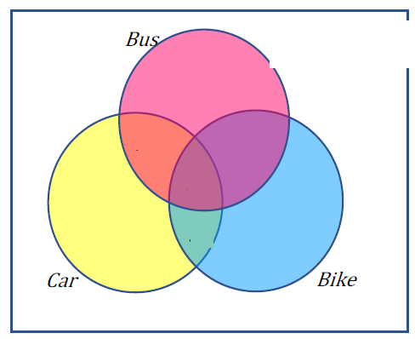In a survey, adults were asked how they travel to work. the recorded data show how many people bused, biked, and/or drove to work. Draw and label a Venn diagram using the information in the table.

How many adults are in the survey?

One hundred fifty people were surveyed and asked if they believed in UFOs, ghosts, and Bigfoot. The following results were recorded.

• 43 believed in UFOs • 44 believed in ghosts • 25 believed in Bigfoot

• 10 believed in UFOs and ghosts • 8 believed in ghosts and Bigfoot

• 5 believed in UFOs and Bigfoot • 2 believed in all three

Draw and label a Venn diagram to determine how many people believed in **at least one** of these things.



Let *A* = {1, 2, 3, 4, 5, 6} and *B* = {2, 4, 6, 8}. What is the cardinality of

n(*B*)*=*? n(*A* ⋃ *B*)*=* ?  n(*A* ⋂ *B*)*=*?

The Venn diagram here shows the cardinality of each set.

Find the cardinality of following

n(*A* ⋂ *C*)

n(*B* ⋃ *C*)

n(*A* ⋂ *B* ⋂ *Cc*)

n(*A* ⋂ *Bc* ⋂ *C*)

If n(G) = 20, n(H) = 30, n(*G* ⋂ *H*) = 5, find n(*G* ⋃ *H*) . Sketch

A survey asked people what alternative transportation modes they use.

Using the data to complete a Venn diagram

30% use the bus 20% ride a bicycle 25% walk

5% use the bus and ride a bicycle 10% ride a bicycle and walk

12% use the bus and walk 2% use all three

then determine

what percent of people only ride the bus?

how many people don’t use any alternate transportation.

|  |  |  |
| --- | --- | --- |
| Overlapping Sets: Sets overlap if they have members in common.  Qualified Proposition: “Some students who live in SE Portland take MTH 105.” | Disjoint Sets: Sets are disjoint if they have no members in common.  Qualified Proposition: “No cats are Dogs.” | Subsets: If a set is completely contained in another set, it is called a subset.  Qualified Proposition: “All Maples are Trees.” |

**Assessment Target 26**

**I can…** apply sets and Venn diagram to solve logic problem

Write the notation for the selected



Let A = {1, 2, 3, 4, 5} B = {1, 3, 5} C = {4, 6}. Find the cardinality of the given set.

n(*A*) n(*B*) n(*A* ⋃ *C*) n(*A* ⋂ *C*)

If n(G) = 5, n(H) = 8, n(*G* ⋂ *H*) = 4, find n(*G* ⋃ *H*). Sketch

A survey was given asking whether people watch movies at home from Netflix, Redbox, or a video store. Draw Venn Diagram and use the results to determine how many people use Redbox.

• 52 only use Netflix, 62 only use Redbox

• 24 only use a video store, 16 use only a video store and Redbox

• 48 use only Netflix and Redbox, 30 use only a video store and Netflix

• 10 use all three, 25 use none of these